Fractal Cuts

The introduction:

The best way to introduce this task is to have one of the constructions ready-made. It can be passed round and then discussion can be focussed on how to construct such a design. The finished article can be used to demonstrate both multiplication of fractions and equivalent fractions. It is of course a simple example of a fractal and these can be discussed as well – even better if you have a poster to demonstrate more complicated examples.

The task:

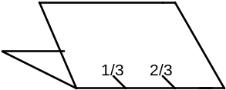Take a piece of A4 card and fold in half width ways. Now measure accurately the width, and split the fold into thirds. Label 0, ¹/₃, ²/₃ and 1.

Now cut half way along the ¹/₃ and ²/₃ markers. Fold the resultant ‘flap’ inside out.
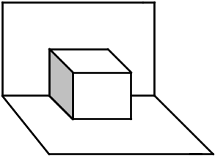

There will now be folds (about 7cm long) in five different places. Each of these should now be split into three equal parts, starting the recurring pattern.

At this point label the resultant nine markers along the first fold in ninths. Equivalent fractions are now marked. Also we can see that one third has been split into thirds, and the labelling demonstrates that a third of a third is a ninth. Develop multiplication of fractions from this and compare two thirds of one third and so on.

Back to the cutting: the new marks are now the positions of cuts that reach about one third of the way along the ‘flap’ created in the first stage (about 2.5cm). Longer than this and the construction will fall apart! Again, fold the new flaps inside out.
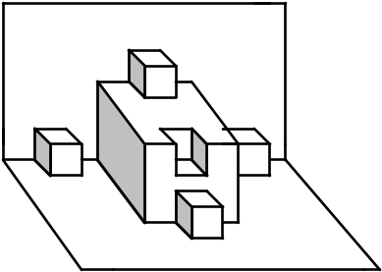
Repeat the process on each of the 25 new folds, splitting into 27ths. This will usually occupy one hour, but I have had pupils starting on the next stage too. No extension beyond that should be necessary.

